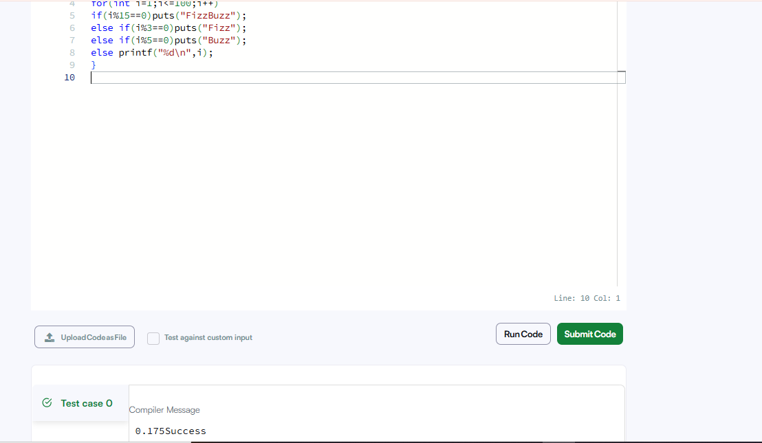

CODE-

#include<stdio.h>
int main(){
for(int i=1;i<=100;i++)
if(i%15==0)puts("FizzBuzz");
else if(i%3==0)puts("Fizz");
else if(i%5==0)puts("Buzz");
else printf("%d\n",i);
}

LINK-

https://www.hackerrank.com/challenges/fizzbuzz/problem

